**Elsevier QE Test**

**TASK 1 Bug Reporting**

Go to <https://www.phptravels.net> and report few of the bugs that you find. For a template use any bug reporting system that you like. Write them in sections below.

**Site is unavailable in case user changes language to Arabic**

**Priority**: Blocker

**Steps to reproduce**:

1. Open main page - https://www.phptravels.net/

2. Change language to the Arabic:

*Expected result:* site is available, all information is in Arabic language

*Actual result:* site is unavailable, only Contact information and that Arabic language is selected is shown.

Additional information: No possibility to switch back to English language. Only one workaround is available - delete cookies and refresh the page

**404 Error code returns when user tries to open Details page for any Hotel**

**Priority**: Blocker

**Steps to reproduce**:

1. Open main page - https://www.phptravels.net/

2. Select Hotels tab in the search panel

3. Fill in City name, Checkin, Checkout and Travelers information (e.g. Berlin, 25-08-2021, 26-08-2021, Travelers Adults 2 Rooms 1 Nationality Indian)

4. Click on Search button

5. Click on the Details button in the first of available results:

*Expected result:* open with hotel and room details is opened

*Actual result:* Error 404 No page found!.

**404 Error code returns when user searches without specifying Nationality**

**Priority**: Blocker

**Steps to reproduce**:

1. Open main page - https://www.phptravels.net/

2. Select Hotels tab in the search panel

3. Fill in City name, Checkin, Checkout and Travelers information (e.g. Berlin, 25-08-2021, 26-08-2021, Travelers Adults 2 Rooms 1)

4. Fill in Travelers information: Adults 1, Rooms 1, Childs 1, Nationality - Select.

5. Click on Search button:

*Expected result:* as Nationality is not marked as required field I expect that page with available results will be opened

*Actual result:* Error 404 No page found!.

Additional information: after this case system returns 404 error for any search, workaround - delete all cookies and refresh the page

**Grammatical errors on the interface**

**Priority**: Minor

**Steps to reproduce**:

1. Open main page - https://www.phptravels.net/

2. Open Hotels tab

3. Check that all words in Hotels search menu are written correctly:

*Expected result:* all words in Hotels search menu are written correctly

*Actual result:* Checkin (should be "Check-in"), Checkout (should be "Check-out"), Travellers (should be "Travelers"), Childs (should be "Children")

**Wrong boundary values in Price filter for Hotels search**

**Priority**: High

**Steps to reproduce**:

1. Open main page - https://www.phptravels.net/

2. Open Hotels tab

3. Fill in valid values for search (e.g. City name - "Singapore", Checkin - "27-08-2021", Checkout - "28-08-2021", Adults - 2, Rooms - 1)

4. Click on Search button

5. Check boundary values in Price filter:

*Expected result:* maximum value must be equal to the most expensive price from the results, minimum value must be equal to the cheapest price from the results

*Actual result:* boundary values in Price filter do not correspond to prices from the results (probably, they are in another currency)

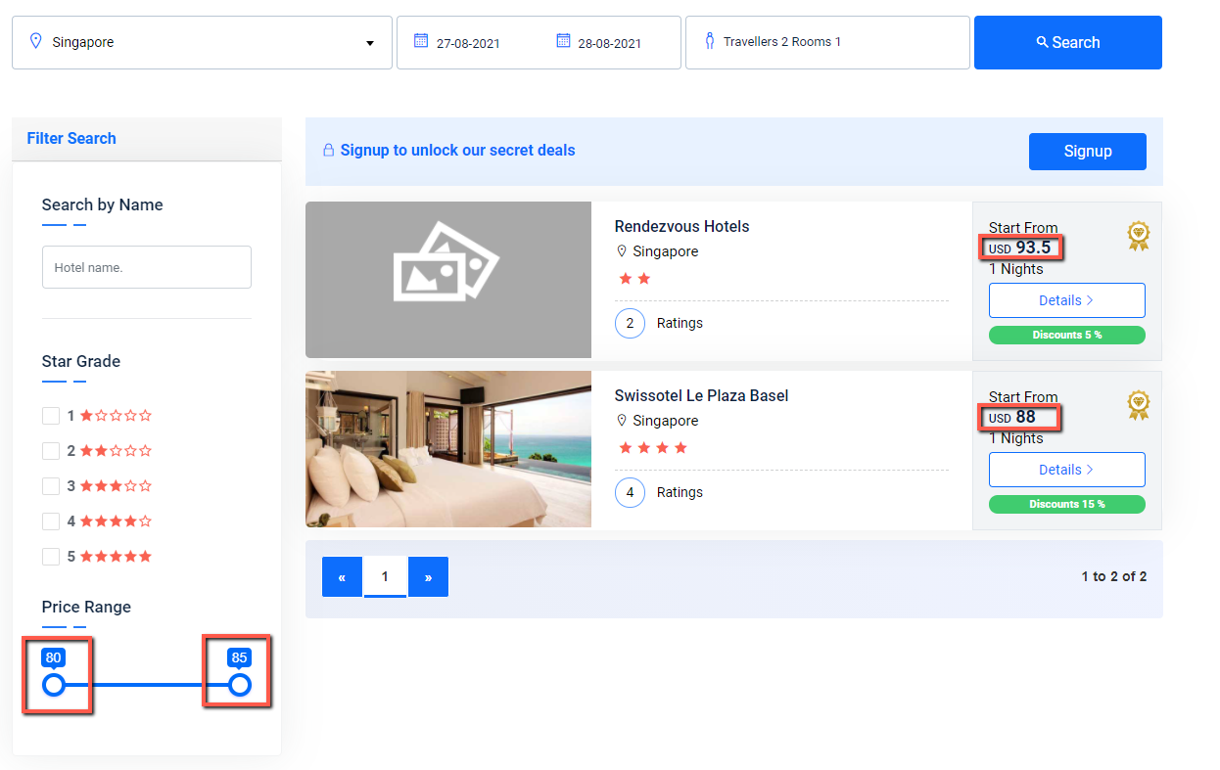

**Email format is not checked in Signup form**

**Priority**: High

**Steps to reproduce**:

1. Open main page - https://www.phptravels.net/

2. Click on Signup button on the right side of the menu on the top of the page

3. Fill in the following fields with valid information First Name (e.g. John), Last Name (e.g. Smith), Phone (e.g. +1-234-56789), Password (e.g. testPassword), Account Type (e.g. Customer)

4. Fill in the Email with wrong data, e.g. test.email.box

5. Click on Signup button:

*Expected result:* signup request shouldn't be send, message about wrong email should be shown.

*Actual result:* signup request is successfully sent

**User with Customer role can login via Agents login form**

**Priority**: High

**Preconditions**: account with Customer role is created in advance

**Steps to reproduce**:

1. Open main page - https://www.phptravels.net/

2. Select Agents menu on the top of the page

3. Click on Login sub-menu of the Agents menu

4. Fill in Email and Password of user with Customer role

5. Click on Login button:

*Expected result:* User with Customer role shouldn't be able to login as Agent

*Actual result:* user successfully logged in

**Menu on the top of the page is not adapted for mobile browser**

**Priority**: High

**Devices**: IPhone X, IPhone SE, Galaxy S5

**Steps to reproduce**:

1. Open main page - https://www.phptravels.net/

2. On the top of the page click on the arrow sign

3. Check that menu is adapted for mobile browser:

*Expected result:* menu is adapted for mobile browser

*Actual result:* menu is NOT adapted for mobile browser

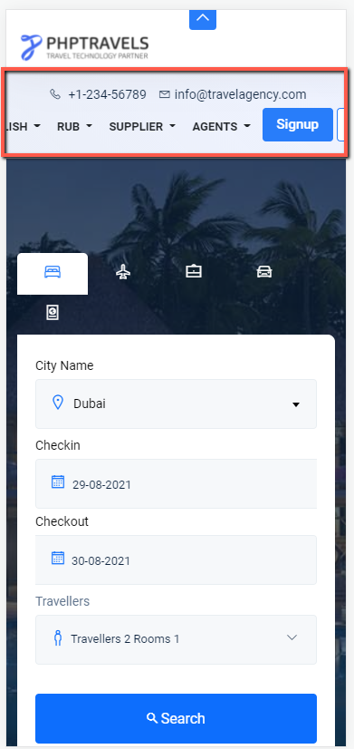

**The main menu crashes when user scrolls up and down the page in a mobile browser**

**Priority**: High

**Devices**: IPhone X, IPhone SE, Galaxy S5

**Steps to reproduce**:

1. Open main page - https://www.phptravels.net/

2. Try to open the main menu

*Actual result:* The menu looks as expected

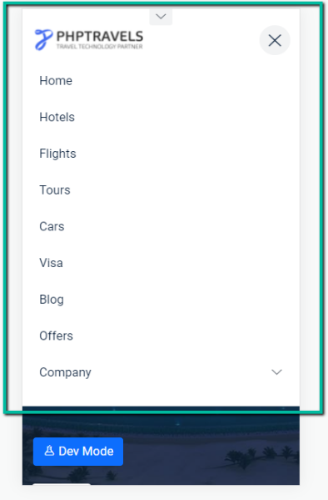

3. Close main menu

4. Scroll down the page

5. Try to open the main menu:

*Expected result:* the menu should look as it was on previous screenshot

*Actual result:* the main menu crashed

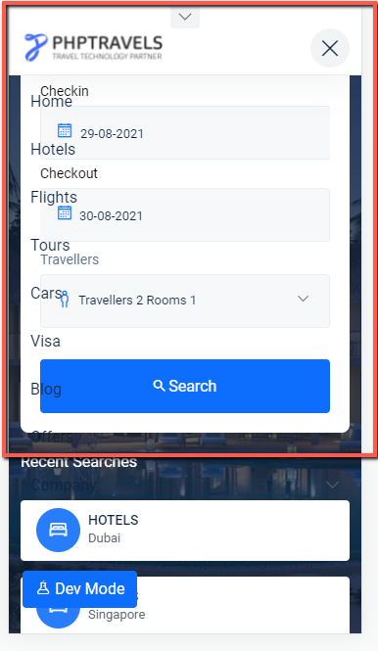

**TASK 2 Manual Test Scripts**

Go to <https://www.phptravels.net/hotels> and write few manual test scripts for the filtering functionality. Write them in sections below.

|  |  |  |  |  |
| --- | --- | --- | --- | --- |
| Test case # | Scenario | Test summary | Testing steps | Expected result |
| TC-01 | Positive | Verify that search results correspond to the initial search criteria | 1. Go to <https://www.phptravels.net/hotels> 2. Fill in City name - "Dubai", Checkin – valid date, Checkout – checkin date + 1 day, Adults - 2, Rooms - 1 3. Click on Search button  4. Check if all results correspond to the search criteria: Dubai, 1 Night, 1 Room | 1. Page is opened 2. Data is filled in  3. Search results are available  4. All results correspond to the search criteria |

|  |  |  |  |  |
| --- | --- | --- | --- | --- |
| Test case # | Scenario | Test summary | Testing steps | Expected result |
| TC-02 | Positive | Verify that search results might be filtered by Hotel name | 1. Go to <https://www.phptravels.net/hotels> 2. Fill in City name - "Dubai", Checkin – valid date, Checkout – checkin date + 1 day, Adults - 2, Rooms - 1 3. Click on Search button  4. Fill in Search by Name field with “Beach” value  5. Check if all results correspond to the filter criteria | 1. Page is opened 2. Data is filled in  3. Search results are available  4. Search by Name filter applied  5. All results correspond to the search criteria |

|  |  |  |  |  |
| --- | --- | --- | --- | --- |
| Test case # | Scenario | Test summary | Testing steps | Expected result |
| TC-03 | Positive | Verify that the same number of hotels is displayed when you remove the Search by Name filter. | 1. Go to <https://www.phptravels.net/hotels> 2. Fill in City name - "Dubai", Checkin – valid date, Checkout – checkin date + 1 day, Adults - 2, Rooms - 1 3. Click on Search button  4. Write down the number of found hotels  5. Fill in Search by Name field with “Beach” value  6. Check if all results correspond to the filter criteria  7. Delete value from Search by Name field  8. Check that the number of displayed hotels = the number of found hotels from Step 4 | 1. Page is opened 2. Data is filled in  3. Search results are available  4. Done  5. Search by Name filter applied  6. All results correspond to the search criteria  7. Value is deleted. Results aren’t filtered  8. the number of displayed hotels = the number of found hotels from Step 4 |

|  |  |  |  |  |
| --- | --- | --- | --- | --- |
| Test case # | Scenario | Test summary | Testing steps | Expected result |
| TC-04 | Positive | Verify that Star Grade filter works as expected | 1. Go to <https://www.phptravels.net/hotels> 2. Fill in City name - "Dubai", Checkin – valid date, Checkout – checkin date + 1 day, Adults - 2, Rooms - 1 3. Click on Search button  4. Select “1 star” checkbox in the Star Grade filter  5. Check if all results correspond to the filter criteria  6. Select “3 stars” and “4 stars” checkboxes in the Star Grade filter  7. Check if all results correspond to the filter criteria  8. Select all checkboxes in the Star Grade filter  9. Check if all results correspond to the filter criteria | 1. Page is opened 2. Data is filled in  3. Search results are available  4. Star Grade filter applied  5. All results are “1 star” hotels  6. Star Grade filter applied  7. All results are “3 stars” and “4 stars” hotels  8. Star Grade filter applied  9. All results correspond to all selected checkboxes |

|  |  |  |  |  |
| --- | --- | --- | --- | --- |
| Test case # | Scenario | Test summary | Testing steps | Expected result |
| TC-05 | Positive | Verify that the same number of hotels is displayed when you remove the Star Grade filter. | 1. Go to <https://www.phptravels.net/hotels> 2. Fill in City name - "Dubai", Checkin – valid date, Checkout – checkin date + 1 day, Adults - 2, Rooms - 1 3. Click on Search button  4. Write down the number of found hotels  5. Select “2 stars” checkbox in the Star Grade filter  6. Check if all results correspond to the filter criteria  7. Remove selection from all checkboxes in the Star Grade filter  8. Check that the number of displayed hotels = the number of found hotels from Step 4 | 1. Page is opened 2. Data is filled in  3. Search results are available  4. Done  5. Star Grade filter applied  6. All results correspond to the search criteria  7. Removed. Results aren’t filtered  8. the number of displayed hotels = the number of found hotels from Step 4 |

|  |  |  |  |  |
| --- | --- | --- | --- | --- |
| Test case # | Scenario | Test summary | Testing steps | Expected result |
| TC-06 | Positive | Verify the Price Range filter boundary values | 1. Go to <https://www.phptravels.net/hotels> 2. Fill in City name - "Dubai", Checkin – valid date, Checkout – checkin date + 1 day, Adults - 2, Rooms - 1 3. Click on Search button  4. Check that maximum value in the Price Range filter equals to the most expensive price from results  5. Check that minimum value in the Price Range filter equals to the cheapest price from results | 1. Page is opened 2. Data is filled in  3. Search results are available  4. Maximum value equals to the most expensive price from results  5. Minimum value equals to the cheapest price from results |

|  |  |  |  |  |
| --- | --- | --- | --- | --- |
| Test case # | Scenario | Test summary | Testing steps | Expected result |
| TC-07 | Positive | Verify that the Price Range filter works as expected | 1. Go to <https://www.phptravels.net/hotels> 2. Fill in City name - "Dubai", Checkin – valid date, Checkout – checkin date + 1 day, Adults - 2, Rooms - 1 3. Click on Search button  4. Move min price boundary of the Price Range filter a bit to the right  5. Check if all results correspond to the filter criteria  6. Move max price boundary of the Price Range filter a bit to the left  7. Check if all results correspond to the filter criteria  8. Move both price boundaries to the right side (maximum price)  9. Check if all results correspond to the filter criteria  10. Move both price boundaries to the left side (minimum price)  11. Check if all results correspond to the filter criteria | 1. Page is opened 2. Data is filled in  3. Search results are available  4. The Price Range filter applied  5. All results correspond to the filter criteria  6. The Price Range filter applied  7. All results correspond to the filter criteria  8. The Price Range filter applied  9. All filtered results have maximum price  10. The Price Range filter applied  11. All filtered results have minimum price |

|  |  |  |  |  |
| --- | --- | --- | --- | --- |
| Test case # | Scenario | Test summary | Testing steps | Expected result |
| TC-08 | Positive | Verify that filtering functionality is not available if the search does not return any results | 1. Go to <https://www.phptravels.net/hotels> 2. Fill in City name - "Berlin", Checkin – valid date, Checkout – checkin date + 1 day, Adults - 2, Rooms - 1 3. Click on Search button  4. Check that filtering functionality is not available | 1. Page is opened 2. Data is filled in  3. Search didn’t return any results  4. Filtering functionality is not available |

**TASK 3 API Test**

You have an API request for authentication. Please add missing parts and write a few main test scenarios:  
Request ->  
Method: *POST (using POST we sent request parameters in message body which makes request more secure)*  
Headers: *Cache-Control: no-cache (request shouldn’t be cached), origin (contains only the server name, shows to the server that request is from the allowed site)*  
*https*://someUrl/login *(nothing else should be passed in the URL )*  
{  
“name”: “some name”,  
“pass”: “password”  
}  
Response ->  
*200*

*Headers: X-Frame-Options: DENY (browser should NOT be allowed to render a page in iframes), Access-control-allow-origin*

*Response data: Expires (date), Issue date (date), Token, Refresh token (in case if OAuth is used)*

**TASK 4 Test Automation**

Go to <http://automationpractice.com/index.php> and using Java, write an automated test/s to verify that summer dresses can be added to the cart and it’s possible to proceed to the Sign in section.

Please, check the following link: <https://github.com/PavelTomarovskii/elsevier_test_automation>

There you may find a maven project implemented using Java 8 + Junit5 + WebDriver + Gherkin (Cucumber).

To execute the test cases please open src 🡪 main 🡪 java 🡪 runner 🡪*TestRunner.java* class click on green play button on the left side and select “Run ‘TestRunner’”

